Article. Product Catalogue

1

#01

KALINA.
THE PRODUCT CATALOG
w w w .w ebsit e .c om

Article. Product Catalogue

Introduction

Some stores compile lists of products you can buy from them. These lists (often in book form) are some-
times accompanied by descriptions and photos of the products. You may see this book described as either a catalog or a catalogue. Which is the proper way to spell the word—catalog or catalogue

Which spelling do you think looks best? Your answer might depend on where you live. In the United States, catalog is the most common way to spell the word. In other English-speaking countries, catalogue is most popular.

Years ago, American writers began to drop the -ue ending from many words to simplify the spelling. Now, words like analog, dialog, and catalog are common in American English.

Thanks

Article. Product Catalogue

KALINA.

Some stores compile lists of products you can buy from them. These lists (often in book form) are sometimes ac-
companied by descriptions and photos of the products. You may see this book described as either a catalog or a cata-
logue. Which is the proper way to spell the word—catalog or catalogue

Which spelling do you think looks best? Your answer might depend on where you live. In the United States, catalog
is the most common way to spell the word. In other En- glish-speaking countries, catalogue is most popular.

Years ago, American writers began to drop the -ue ending
from many words to simplify the spelling. Now, words like a nalog, dialog, and catalog are common in American En-
glish.
One of the best ways to learn how to use a word is to look at
examples. Here are some ways to use catalog (and catalogue) in a sentence. You will notice that the definition of catalog extends beyond a book of products for sale. A catalog can be any com-
pilation of items organized in a systematic manner. That’s why
the list of books available at your library might be organized in a digital catalog. It can also be used as a verb meaning to make a
catalog of items or to add an item to a catalog. You can catalog anything!

Product Catalogue
Article.
KALINA.

w w w .w ebsit e .c om

Article. Product Catalogue

TABLE OF CONTENT

Some stores
01
compile lists of products you can buy from them.
Some stores 02
compile lists of products you can buy from them.
Some stores 03
compile lists of products you can buy from them.

Some stores
04
compile lists of products you can buy from them.

w w w .w ebsit e .c om

Article.
Product Catalogue

02

Article
www.cataloguebroichure.com
modern Furnitutre

Article. Product Catalogue

a sentence. You will notice that the definition of catalog extends beyond 01
a book of products for sale. A catalog can be any compilation of items organized in a systematic manner. That’s why the list of books available at your library might be organized in a digital catalog. It can also be used as a verb meaning to make a catalog of items or to add an item to a catalog.
You can catalog anything!

Article.
8
Product Catalogue
Head Office

Article. Product Catalogue

Article
modern Furnitutre

Head Office

a sentence. You will notice that the definition of catalog extends beyond a book of products for sale. A catalog can be any compilation of items or- ganized in a systematic manner. That’s why the list of books available at your library might be organized in a digital catalog. It can also be used as a verb meaning to make a catalog of items or to add an item to a catalog. You can catalog anything!

Product Catalogue
Article.

Article

Head Office

a sentence. You will notice that the definition of catalog extends beyond a book of products for sale. A catalog can be any compila- tion of items organized in a systematic manner. That’s why the list of books available at your library might be organized in a digital
catalog. It can also be used as a verb meaning to make a catalog of items or to add an item to a catalog. You can catalog anything!

Article. Product Catalogue

Head Office

Article.

Product Catalogue

Article
modern Furnitutre

Article. Product Catalogue

13

02 a sentence. You will notice that the definition of catalog extends beyond a book of products for sale.

A catalog can be any compilation of items organized in a
systematic manner. That’s why the list of books available at your library might be organized in a digital catalog. It can also be used as a verb meaning to make a catalog of items or to add an item to a catalog. You can catalog anything!

www.cataloguebroichure.com

Article. Product Catalogue

The Other Products

Article. Product Catalogue

Article
modern Furnitutre

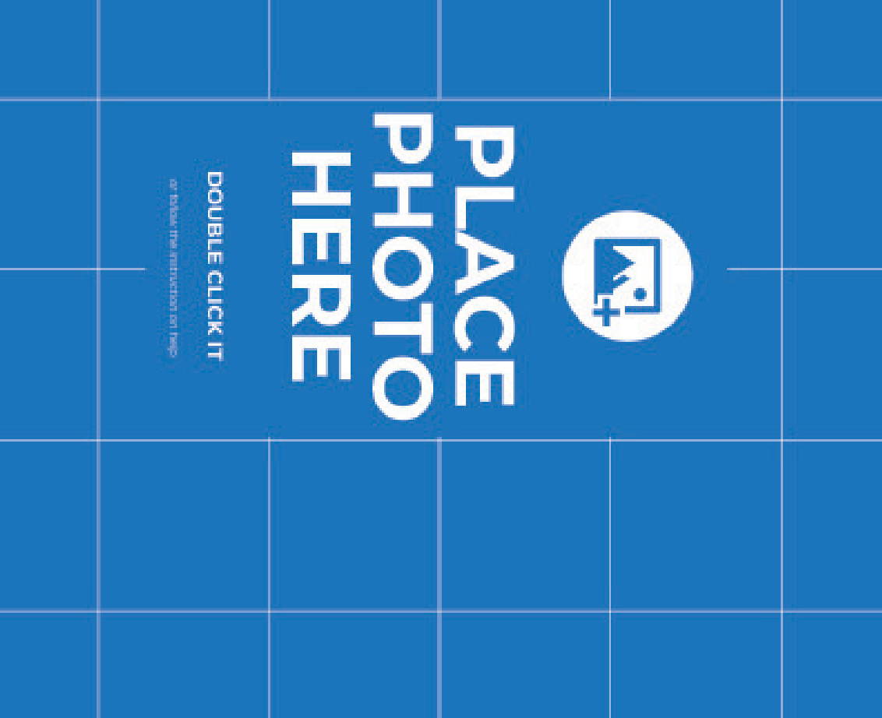
Article. Product Catalogue
Modern Furnitures
16

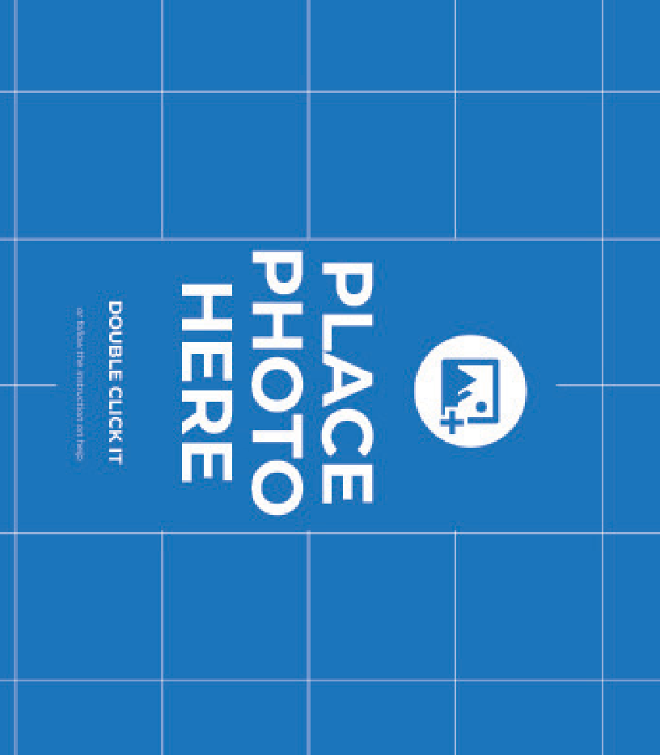

Article. Product Catalogue

a sentence. You will notice that the definition of catalog extends beyond a book of products for sale. A catalog can be any compilation of items
organized in a systematic manner. That’s why the list of books available at your library might be organized in a digital catalog. It can also be used as a verb meaning to make a catalog of items or to add an item to a catalog. You can catalog anything!

Urban- Woods

Article.

The Other Products Under Floor
Modern Furnitures

Article.

Modern Furnitures 1 Modern Furnitures 1

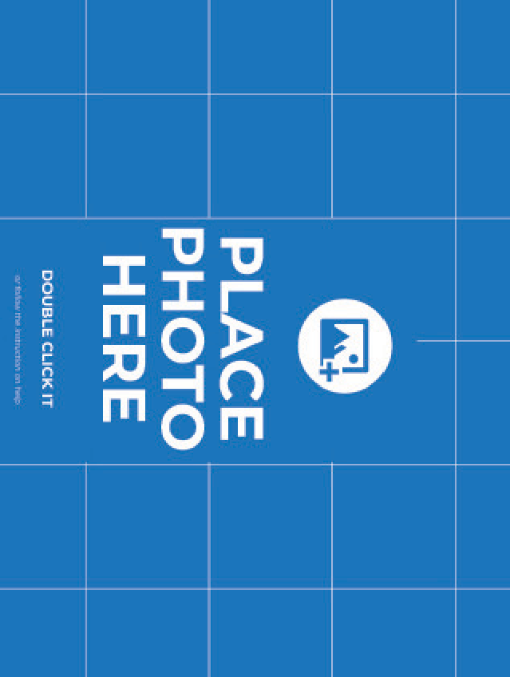
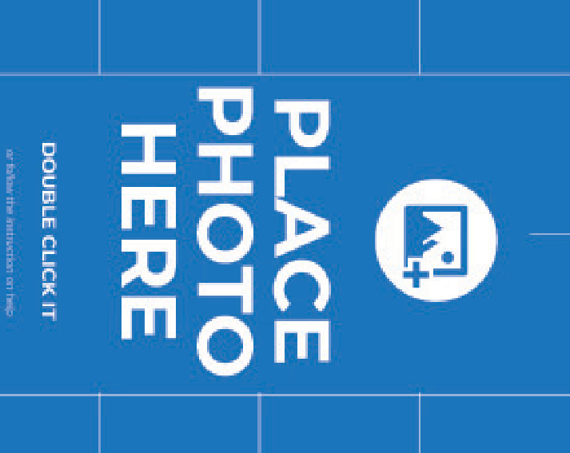
Article. Product Catalogue
20

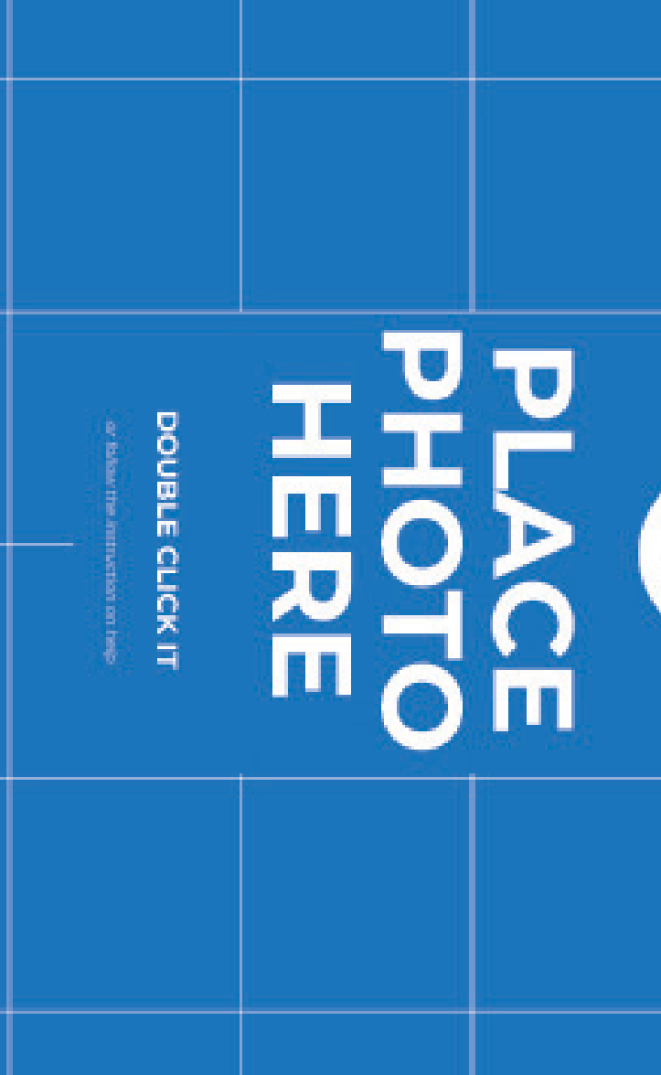

Article. Product Catalogue

21

The Other Products Under Floor
Modern Furnitures

04

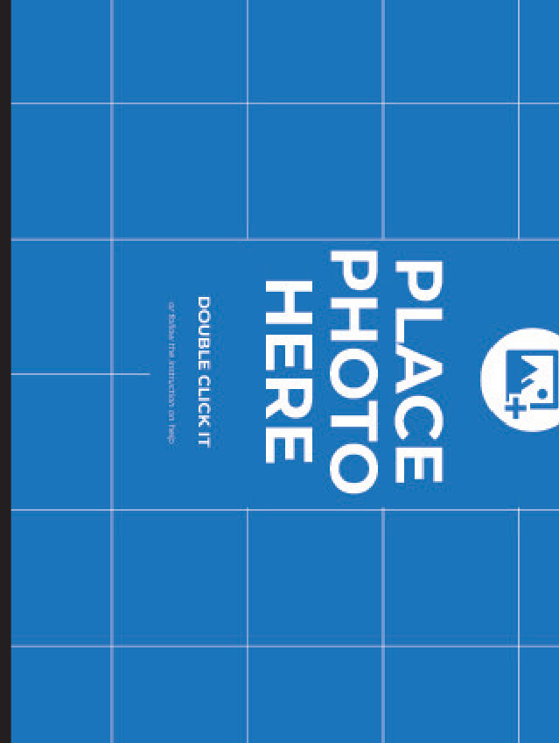
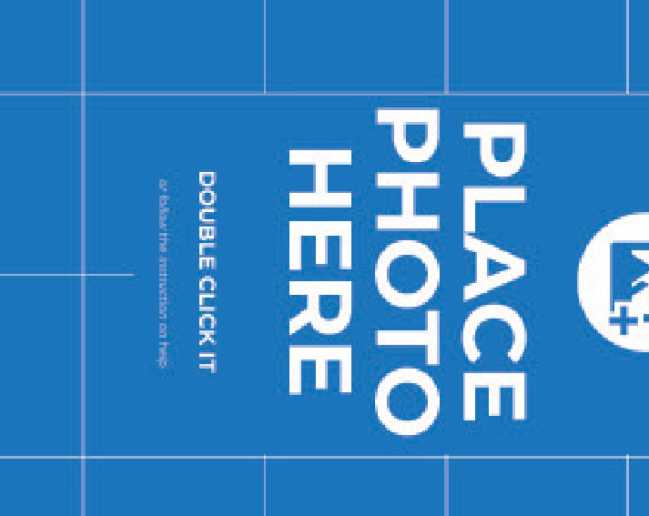
Article. Product Catalogue
22

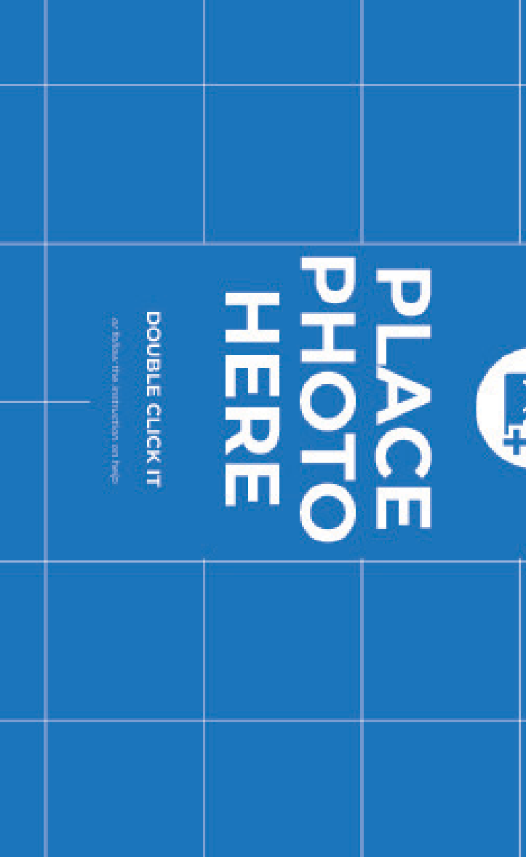
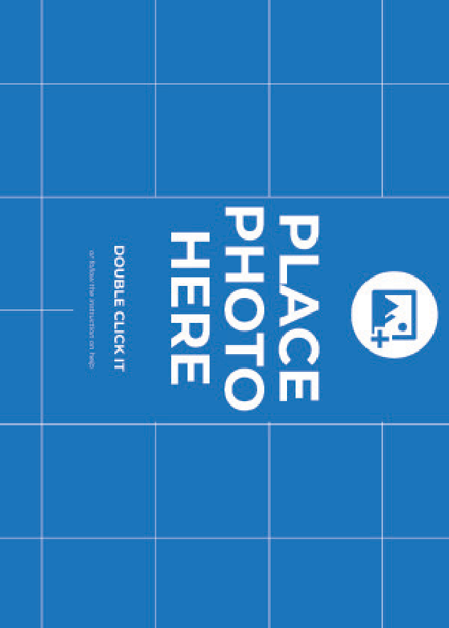

Article. Product Catalogue
23
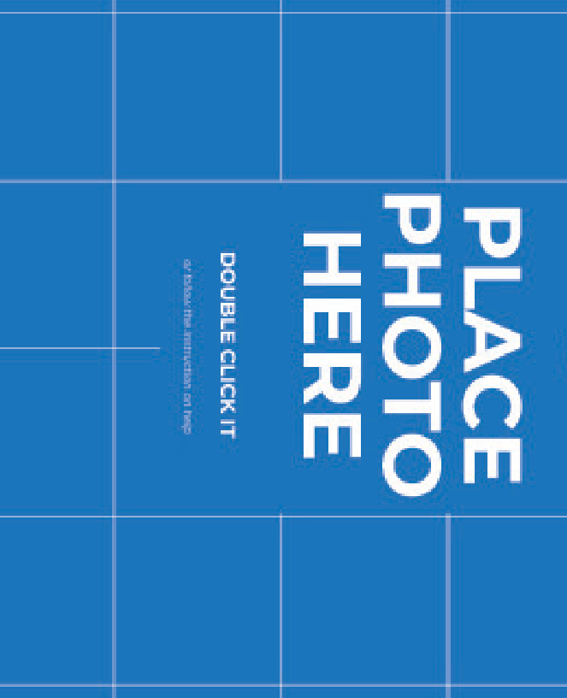

Article. Product Catalogue

The Other Products Under Floor.

Mac is my design studio, writing room, communications center, and remote office. I’m always interested in finding better tools for my job — tools that are as beautiful as they are functional. Many people hate switching apps,
but I love it. A few months ago, I was a loyal user of the collaborative inter- face design app Sketch; now I use Figma. A couple years ago, I was creating flow diagrams in Omnigraffle; now it’s Overflow. I’ve used every email app under the sun and switched note-taking apps more times than I care to
admit.

Article. Product Catalogue

Living & Study Room.
Modern Furnitures

Mac is my design studio, writing room, com- munications center, and remote office. I’m al- ways interested in finding better tools for my job — tools that are as beautiful as they are
functional. Many people hate switching apps, but I love it. A few months ago, I was a loyal
user of the collaborative interface design app Sketch; now I use Figma. A couple years ago,
I was creating flow diagrams in Omnigraffle; now it’s Overflow. I’ve used every email app
under the sun and switched note-taking apps more times than I care to admit.

Article. Product Catalogue

26

Modern Furnitures

Article. Product Catalogue

The Other Products Under Floor Simplest.

Mac is my design studio, writing room, com- munications center, and remote office. I’m al- ways interested in finding better tools for my job — tools that are as beautiful as they are
functional. Many people hate switching apps, but I love it. A few months ago, I was a loyal
user of the collaborative interface design app Sketch; now I use Figma. A couple years ago,
I was creating flow diagrams in Omnigraffle; now it’s Overflow. I’ve used every email app
under the sun and switched note-taking apps more times than I care to admit.

Mac is my design studio, writing room, com- munications center, and remote office. I’m al- ways interested in finding better tools for my job — tools that are as beautiful as they are
functional. Many people hate switching apps, but I love it. A few months ago, I was a loyal
user of the collaborative interface design app Sketch; now I use Figma. A couple years ago,
I was creating flow diagrams in Omnigraffle; now it’s Overflow. I’ve used every email app
under the sun and switched note-taking apps more times than I care to admit.

You’re using a password manager, right? Right? If you’re not, this is the one to get.
1Password recently switched to a subscription model (who hasn’t?), a move that frustrated
some users. Still, for something as important as the security of your password data, I think it’s worth it to know the app is up to date on all the latest threats. I use 1Password to store everything from logins to software licenses, credit cards to important documents. It has robust browser integration and cross-plat-
form.

Article.

Living Room.
Product Catalogue

Modern Furnitures

talogue a C
t

oduc r P
Article.

The Other Products Under Floor Simplest.

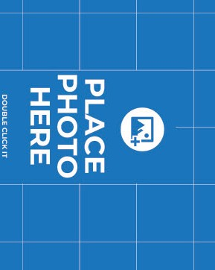Article. Product Catalogue
Wood.
30

Article. Product Catalogue

Mac is my design studio, writing room, communications center,

and remote office. I’m always interested in finding better tools for my job — tools that
are as beautiful as they are functional. Many people hate switching apps, but I love it. A few months ago,

Article. Product Catalogue

Article
modern Furnitutre

Article. Product Catalogue

33

03 www.cataloguebroichure.com

Article

Article.

Desk

Product Catalogue
Article.

Mac is my design studio, writing room, communications center, and remote office. I’m always interested in finding better tools for my job — tools that
are as beautiful as they are functional. Many people hate switching apps, but I love it. A few months ago, I was a loyal user of the collaborative interface
design app Sketch; now I use Figma. A couple years ago, I was creating flow diagrams in Omnigraffle; now it’s Overflow. I’ve used every email app under the sun and switched note-taking apps more times than I care to admit.

Unique Product

Article. Product Catalogue
36

Mac is my design studio, writing room, communications center,
The Other Products Under Floor Simplest. uniique
and remote office. I’m always interested in finding better tools for my job — tools that are as beautiful as they are functional. Many people hate switching apps, but I love it. A few months ago, I was a loyal user of the collaborative interface design app Sketch; now I use Figma. A couple years ago, I was creating flow diagrams in
Omnigraffle; now it’s Overflow. I’ve used every email app under the sun and switched note-taking apps more times than I care to admit.

Article. Product Catalogue

37

Article.

The Other Products Under Floor Simplest. uniique

Article. D E
S K

Article. Product Catalogue

40

THE PRODUCT CATALOG

VISIT OUR STORE

w w w .w ebsit e .c om

МАРКЕТИНГ-КИТ ОТ “ПАНДА-КОПИРАЙТИНГ”

СТОИМОСТЬ “ПОД КЛЮЧ” ОТ $130 ЯЗЫКИ: РУССКИЙ, АНГЛИЙСКИЙ, ФРАНЦУЗСКИЙ, НЕМЕЦКИЙ

СИЛЬНЫЙ ПРОДАЮЩИЙ ТЕКСТ В 5 СТИЛЯХ
ГОТОВНОСТЬ ОТ 72 ЧАСОВ ПОДБОР ИЗ 20 000+ ПЛАТНЫХ ЛИЦЕНЗИОННЫХ
PRO-ШАБЛОНОВ

Дополнительно: оформление под брендбук компании или подбор сочетаний цветов для создания вашего фирстиля и оформления

Также “под ключ”: презентации, брошюры, White Paper, буклеты, коммерческие предложения

customers@petr-panda.ru Главный сайт проекта: petr-panda.ru

MARKETING KIT BY PANDA COPYWRITING PROJECT

A TURNKEY COST STARTS AT $130 LANGUAGES: RUSSIAN, ENGLISH, FRENCH, AND GERMAN

STYLES OF THE POWERFUL SELLING 5 TEXT
AN AVAILABILITY FROM 72 HOURS A SELECTION OF 20,000+ PAID LICENSED PRO TEMPLATES

Additionally: design for a company’s brand book or selection of color combinations to create your corporate identity and design

Plus: presentations, brochures, White Paper, booklets, and business proposals

customers@petr-panda.ru
The main project’s website: petr-panda.ru

